University of Central Missouri

Department of Computer Science & Cybersecurity

CS5710 Machine Learning

Fall 2025

Home Assignment 4.

Student name: Menaka Naga Sai Pothina

700772418

Part A: Calculation

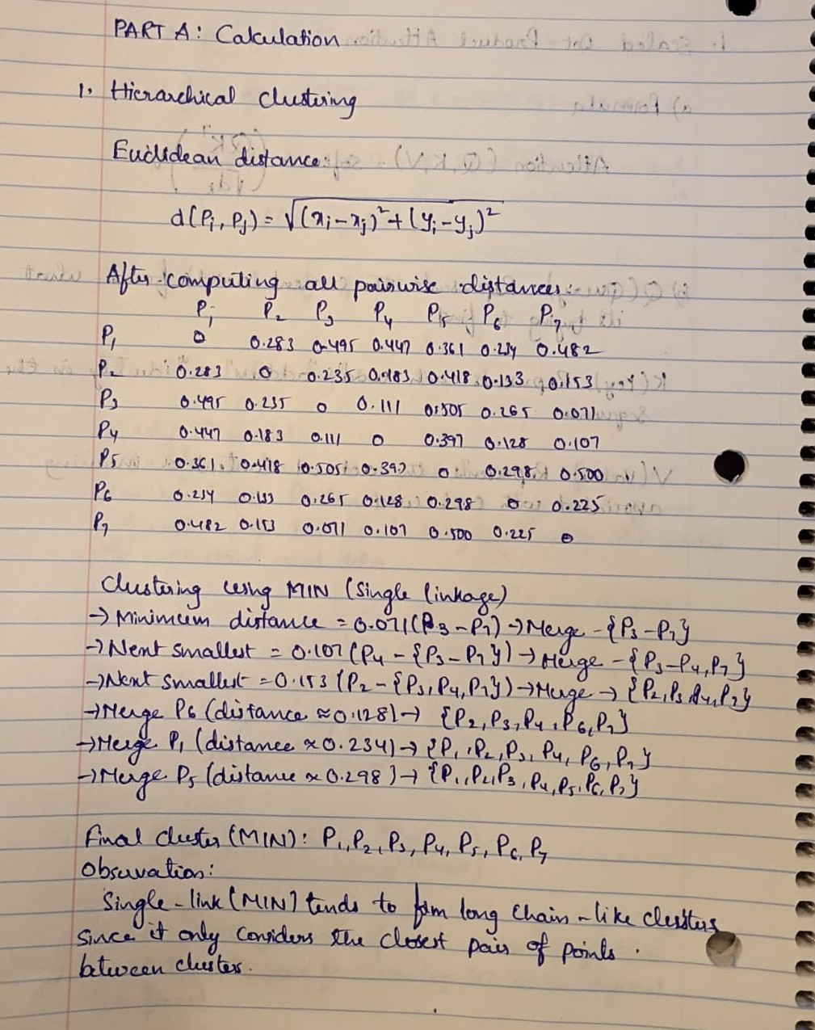
Q1. Find the cluster using the Average and MIN technique. Use Euclidean distance to build the complete distance matrix, updated the distance matrix to the final step and draw the dendrogram for each.
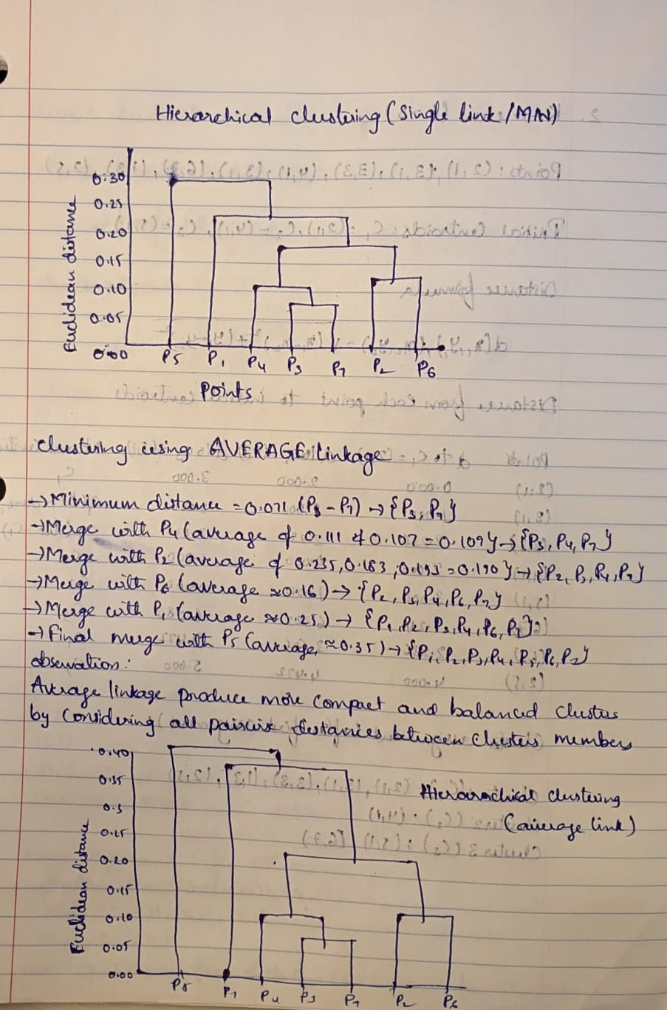

Q2. We have the following 2D data points:
Points: (2,1), (3,1), (3, 3), (4, 1), (5, 1), (6,7), (1,3), (2,5)
for K =3:
Centroid1: (2,1)
Centroid 2: (4, 1)
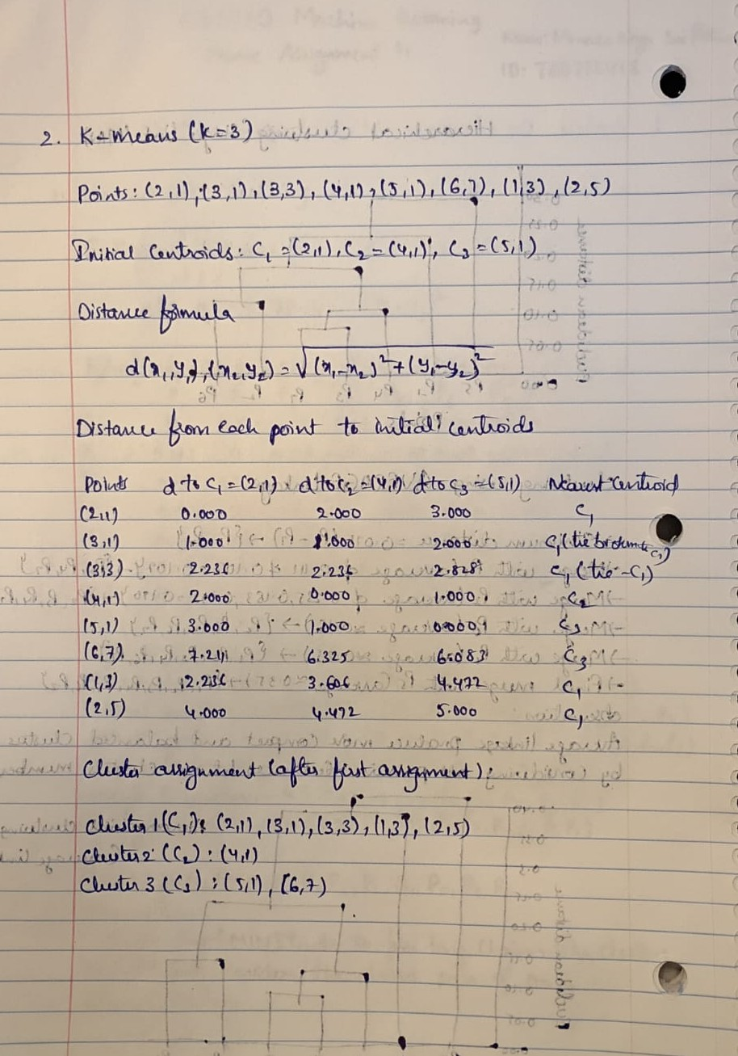
Centroid 3: (5, 1)
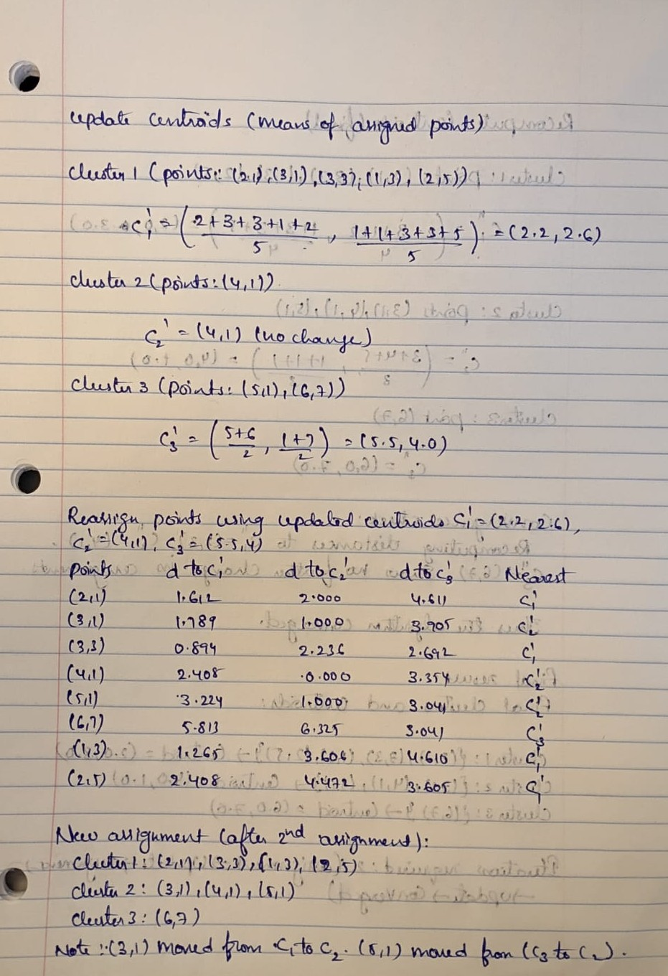
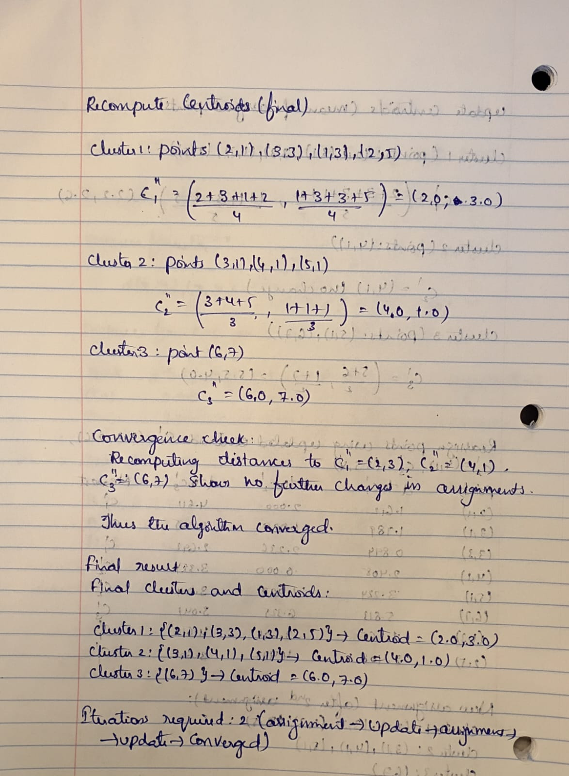

Part B — Short-Answer

Q1.
a) Agglomerative hierarchical clustering
- Bottom-up approach: each point starts as its own cluster; repeatedly merge the two closest clusters until one cluster or stopping criterion. Produces a dendrogram showing merge sequence and distances.

b) Divisive hierarchical clustering
- Top-down approach: start with one cluster containing all points; recursively split clusters into subclusters (usually by maximizing inter-cluster separation) until singleton clusters or stopping criterion are reached. Also yields a dendrogram showing splits.

c) Which is more commonly used and why?
- Agglomerative is more commonly used because it is conceptually simpler to implement, typically more efficient in practice for small-to-moderate datasets, and many well-understood linkage methods exist (single, complete, average). Divisive methods can be more computationally expensive and require an effective splitting criterion.

Q2.

a) Inter-cluster distance should be maximized to make clusters well-separated (larger between-cluster distances indicate clearer separation).

b) Intra-cluster distance should be minimized so members within a cluster are similar (compact clusters). Good clustering aims for low intra-cluster variance and high inter-cluster separation.

Q3.

a) Definitions
- Single-link (nearest neighbor): cluster distance = minimum distance between any pair of points (one from each cluster). Example: merge clusters whose closest members are nearest.
- Complete-link (furthest neighbor): cluster distance = maximum distance between any pair of points (one from each cluster). Example: merge clusters only when their farthest points are close enough.
- Average-link: cluster distance = average pairwise distance between points in the two clusters. Example: uses mean pairwise distances to decide merges.

b) Single-link strength & weakness
- Strength: can discover non-spherical, chain-like clusters and is less likely to split elongated clusters.
- Weakness: susceptible to chaining effect — a single link between distant points can merge dissimilar clusters, producing poor compactness.

Q4.

a) Role of tokenization
- Tokenization segments raw text into tokens (words/punctuation). Example: splitting "Don't stop." into ["Do", "n't", "stop", "."] (or ["Don't","stop","."] depending on tokenizer) — this is the basic input for downstream tasks like POS tagging and NER.

b) Stemming vs. Lemmatization (speed vs. accuracy)
- Stemming: faster, rule-based, produces stems that are not always valid words (e.g., running → run or running → run but sometimes studies → studi), lower accuracy for semantics.
- Lemmatization: slower (requires POS/context and dictionary/WordNet), returns canonical dictionary forms (better → good, ran → run), higher accuracy and better for tasks requiring semantics (NER, POS).

Q5.

a) Word-sense ambiguity
- When a word has multiple meanings (senses). Example: bank — financial institution vs. river bank.

b) Why pronoun reference ambiguity confuses a model
- Pronouns (he, she, it, they) lack explicit semantic content and depend on discourse context; if the model lacks discourse tracking, gender/number cues, or world knowledge, it may pick the wrong antecedent, causing downstream errors (incorrect coreference, wrong sentiment target, etc.).

Q6.
a) Why POS tagging cannot be solved by predicting each token independently
- Because POS labels are interdependent: the correct tag for a token often depends on its neighbors and global context (e.g., determiner + noun vs. verb sequences). Independent per-token predictions ignore syntactic constraints and common transitions, increasing errors.
b) Example of mutually dependent decisions
- Deciding whether can is a NOUN or VERB in can you can a can — the correct tags for each can depend on the tags of surrounding tokens (e.g., modal verb can followed by pronoun → likely modal; a before noun → the following can likely a noun). Enforcing global constraints (sequence models) reduces ambiguity.

Part C — Coding
Q1.
Write Python code to perform the following steps:
- Segment into tokens
- Remove stopwords
- Apply lemmatization (not stemming)
- Keep only verbs and nouns (use POS tags)
Input text:
"John enjoys playing football while Mary loves reading books in the library."
# Requires: nltk
# If running locally first time, run:
# pip install nltk
# python -c "import nltk; nltk.download('punkt'); nltk.download('averaged_perceptron_tagger'); nltk.download('wordnet'); nltk.download('omw-1.4'); nltk.download('stopwords')"

import nltk
from nltk.tokenize import word_tokenize, sent_tokenize
from nltk.corpus import stopwords, wordnet
from nltk.stem import WordNetLemmatizer
from nltk import pos_tag

def get_wordnet_pos(treebank_tag):
if treebank_tag.startswith('J'):
return wordnet.ADJ
elif treebank_tag.startswith('V'):
return wordnet.VERB
elif treebank_tag.startswith('N'):
return wordnet.NOUN
elif treebank_tag.startswith('R'):
return wordnet.ADV
else:
return wordnet.NOUN

text = "John enjoys playing football while Mary loves reading books in the library."

# 1. sentence segmentation + tokenization
sents = sent_tokenize(text)
tokens = word_tokenize(text)

# 2. remove stopwords (and punctuation)
stop_words = set(stopwords.words('english'))
tokens_alpha = [t for t in tokens if t.isalpha()] # drop punctuation
tokens_nostop = [t for t in tokens_alpha if t.lower() not in stop_words]

# 3. POS tagging
pos_tags = pos_tag(tokens_nostop)

# 4. lemmatize with POS; keep only nouns (N*) and verbs (V*)
lemmatizer = WordNetLemmatizer()
rows = []
for token, pos in pos_tags:
wn_pos = get_wordnet_pos(pos)
lemma = lemmatizer.lemmatize(token, wn_pos)
keep = pos.startswith('N') or pos.startswith('V')
comment = ""
if token.lower() in ('duck','book','playing','reading','enjoys'): # example check for ambiguous words; adjust as needed
comment = "ambiguous: can be NOUN/VERB in other contexts"
if keep:
rows.append((token, lemma, pos, comment))

# Print table
print("token | lemma | POS | comment")
for r in rows:
print(" | ".join(r))

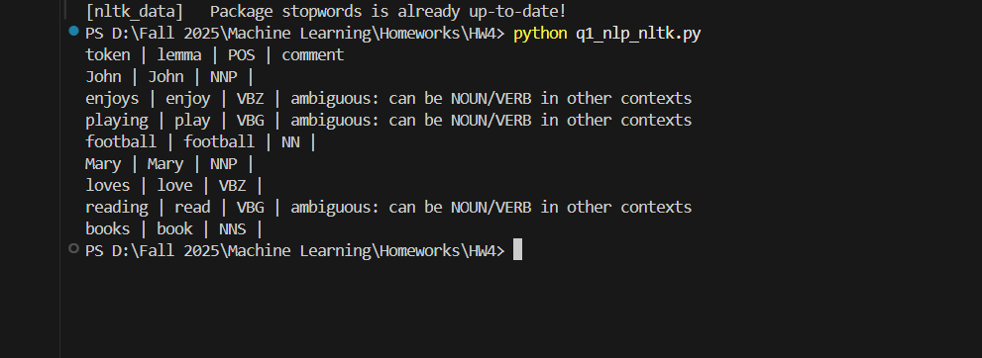

Q2.
Use Python and any NLP model to perform:
- Named Entity Recognition (NER)
- Disambiguation prompt:
If the text contains a pronoun ("he", "she", "they"), print:
"Warning: Possible pronoun ambiguity detected!"
Input text:
"Chris met Alex at Apple headquarters in California. He told him about the new iPhone launch."
# Preferred: spaCy with en_core_web_sm
# Local setup:
# pip install spacy
# python -m spacy download en_core_web_sm

import re

text = "Chris met Alex at Apple headquarters in California. He told him about the new iPhone launch."

# Simple pronoun check
pronouns = {"he","she","they","him","her","them","his","their"}
if any(re.search(r'\b' + p + r'\b', text, flags=re.IGNORECASE) for p in pronouns):
print("Warning: Possible pronoun ambiguity detected!")

# Try spaCy NER, fallback to heuristic
ner_results = []
use_spacy = False
try:
import spacy
nlp = spacy.load("en_core_web_sm")
doc = nlp(text)
for ent in doc.ents:
if ent.label_ in ('PERSON','ORG'):
ner_results.append((ent.text, ent.label_))
use_spacy = True
except Exception as e:
# fallback: capitalized tokens or known orgs
tokens = re.findall(r'\b[A-Z][a-zA-Z0-9_]+\b', text)
for t in tokens:
if t in ("Apple",):
ner_results.append((t, "ORG"))
elif t.lower() in ("iphone",):
ner_results.append((t, "PRODUCT"))
else:
ner_results.append((t, "PERSON"))

print("NER results:", ner_results)

# Coreference heuristic:
# Alias map example (not used here but pattern shown)
alias_map = {"Mr. Robin":"Christopher Robin","Chris":"Christopher Robin"}

# Split sentences
sentences = re.split(r'(?<=[.!?])\s+', text.strip())
person_mentions = [] # list of (mention_text, sent_id, char_index)
for si, s in enumerate(sentences):
for m in re.finditer(r'\b([A-Z][a-z]+)\b', s):
tok = m.group(1)
if tok in ("Apple","California","iPhone"): # skip non-persons
continue
person_mentions.append((tok, si, m.start()))

# For each pronoun, link to nearest preceding PERSON by sentence:
pronoun_links = []
for si, s in enumerate(sentences):
for m in re.finditer(r'\b(he|she|him|her|they|them|his|their)\b', s, flags=re.IGNORECASE):
pron = m.group(1)
antecedent = None
for p in reversed(person_mentions):
if p[1] <= si:
antecedent = p[0]
break
pronoun_links.append(((pron.lower(), si), antecedent))

print("Pronoun links (heuristic):")
for pl in pronoun_links:
print(f"{pl[0]} -> {pl[1]}")

# Normalized paragraph (replace pronouns with [Antecedent] where found)
normalized = text
for pl in pronoun_links:
pron = pl[0][0]
antecedent = pl[1]
if antecedent:
# replace only first match in the relevant sentence
si = pl[0][1]
s = sentences[si]
new_s = re.sub(r'\b' + re.escape(pron) + r'\b', f'[{antecedent}]', s, count=1, flags=re.IGNORECASE)
normalized = normalized.replace(s, new_s, 1)

print("\nNormalized paragraph:\n", normalized)

# Failure case note:
print("\nFailure case note:")
print("The heuristic links pronouns to the nearest preceding PERSON; if multiple people are present "
"or pronoun refers to an entity mentioned earlier in another clause, nearest-by-sentence can be wrong. "
"Fixes: integrate syntactic parsing (to determine grammatical subject), agreement (gender/number), and discourse salience or use a proper coreference model.")

